**VISVESVARAYA TECHNOLOGICAL UNIVERSITY**

**“JnanaSangama”, Belgaum -590014, Karnataka.**



**Web Application Development REPORT**

**on**

**TILES BAZAAR**

***Submitted by***

**ARCHIT MEHROTRA(1BM21CS031)**

**ARYAN RAUNIYAR (1BM21CS034)**

**ASHISH SERU (1BM21CS035)**

**CHANCHAL BHATI (1BM21CS042)**

***Under the Guidance of***

|  |  |
| --- | --- |
| **Prof. Syed Akram**  **Assistant Professor, BMSCE** |  |

***in partial fulfillment for the award of the degree of***

**BACHELOR OF ENGINEERING**

***in***

**COMPUTER SCIENCE AND ENGINEERING**



**B.M.S. COLLEGE OF ENGINEERING**

**(Autonomous Institution under VTU)**

**BENGALURU-560019**

**Oct-2022 to Feb-2023**

**B. M. S. College of Engineering,**

**Bull Temple Road, Bangalore 560019**

(Affiliated To Visvesvaraya Technological University, Belgaum)

**Department of Computer Science and Engineering**



**CERTIFICATE**

This is to certify that the project work entitled “**TILES BAZAAR**” carried out by **ARCHIT MEHROTRA(1BM21CS031), ARYAN RAUNIYAR (1BM21CS034), ASHISH SERU (1BM21CS035) AND CHANCHAL BHATI (1BM21CS42)** who are bonafide students of **B. M. S. College of Engineering.** It is in partial fulfillment for the award of **Bachelor of Engineering in Computer Science and Engineering** of the Visvesvaraya Technological University, Belgaum during the year 2022-2023. The project report has been approved as it satisfies the academic requirements in respect of **Web Application Development (22CS3AEWAD)** work prescribed for the said degree.

Signature of the Guide                 Signature of the HOD

Syed Akram Dr. Jyothi S Nayak

Assistant Professor, Dept. of CSE Prof.& Head, Dept. of CSE

BMSCE, Bengaluru BMSCE, Bengaluru

External Viva

Name of the Examiner                                                                       Signature with date

1._____________________________ ________________________

2. _____________________________ _________________________

**B.M.S. College of EngineerinG**

**DEPARTMENT OF COMPUTER SCIENCE AND ENGINEERING**



***DECALARATION***

We, ARCHIT MEHROTRA(1BM21CS031), ARYAN RAUNIYAR(1BM21CS034), ASHISH SERU(1BM21CS035), CHANCHAL BHATI(1BM21CS042), students of 3rd Semester, B.E, Department of Computer Science and Engineering, B. M. S. College of Engineering, Bangalore, hereby declare that, this Project Work-1entitled "TILES BAZAAR" has been carried out by us under the guidance of Syed Akram, Assistant Professor, Department of CSE, B. M. S. College of Engineering, Bangalore during the academic semester Oct 2022- Feb 2023.

We also declare that to the best of our knowledge and belief, the development reported here is not from part of any other report by any other students.

Signature

ARCHIT MEHROTRA (1BM21CS031)

ARYAN RAUNIYAR (1BM21CS034)

ASHISH SERU (1BM21CS035)

CHANCHAL BHATI (1BM21CS042)

**Abstract**

Website provides information and services related to marbles and granites including their types, uses, and maintenance tips. Products offered include countertops, tiles, and slabs for interior and exterior applications. Custom fabrication and installation services are also available. The website aims to educate customers on the beauty and durability of natural stone surfaces and assist in the selection process.

**Table of Content**

|  |  |  |
| --- | --- | --- |
| **SI No.:** | **TITLE** | **Page No.:** |
| 1 | Chapter 1:  Introduction | 1 |
| 2 | Chapter 2:  Users & Functionalities | 2 |
| 3 | Chapter 3:  Software Requirement Specification | 3 |
| 4 | Chapter 4:  Layouts | 4-6 |
| 5 | Chapter 5:  Conclusion | 7 |
| 6 | References | 8 |

**Chapter 1:**

**Introduction**

The “TILES BAZAAR” website, showcasing the finest selection of marbles and granites for all your design and construction needs. With a vast array of options to choose from, we guarantee to provide you with the highest quality stones, expert advice, and exceptional customer service. We even look after user friendly website, where our website is every easy to access and all the options are provided in the home page.

* 1. AIM

To provide our products D2C and to make it easily accessible to a larger audience nationwide by providing a common go-to platform which is 24/7 available.

* 1. OBJECTIVE

Our objective is to make Marble, Granite and Ceramic tiles and provide their home delivery, a service our competitors usually lack. We accept Payments on Delivery only so that our customers could check and feel satisfied before paying. We intend to build a customer-friendly and trust-worthy website with no frauds throughout.

* 1. Flow of the Report

This report shall take the reader through the following

. System Requirements

. Site Structure

. Layout of the Webpages

. Conclusion

. References

1

**Chapter 2:**

**The project includes supports following users and Functionalities**

**2.1 User (worldwide usage)**

1. In this system user can access to the website being in any apart of world.
2. Here user can give his/her information like name, mail-id, phone no, address etc.
3. All users have individual & unique log in credential to go through the website.
4. User can post their reviews on our website, so that we can work on it afterwards.
5. User can send message the message to us about asking any doubts about the material.
6. User can also report abuse to the system for any unwanted post.

**2.2 Admin**

1. Admin can modify any data and delete unwanted post and even can block users. Admin can add users and provide them user id and password via OTP confirmation which will be required by the users for accessing this website.
2. Admin can block any user. In this system developer is a part for developing the application. Every developer has a permission to access all data of database of TILES BAZAAR and also a permission for create, delete, update and many other features for betterment of security and future upgradation.

2

**Chapter 3:**

SOFTWARE REQUIREMENT SPECIFICATION (SRS)

3.1 Operating Environment

This application will be operating in webpages through browser. The TILES BAZAAR is a web application and can be operated through browser in web pages. The only requirement to use this website would be the internet connection and a device which can access high speed internet.

3.2 Requirement

Software Configuration:

This software package is developed using HTML, CSS, as front end, JavaScript, jQuery as client-side validation, Ajax as server-side validation, PHP as business logic, MySQL as to store the database and Apache as web server.

Operating System: Windows XP, Windows 7, Windows 8, Windows 10

Front end: HTML, CSS

Client-side Validation: JavaScript, jQuery

Server-side Validation: Ajax

Business Logic: PHP

Database: MySQL

Web Server: Apache

Hardware Configuration:

Processor: Core i7, 2.50GHz

Hard Disk: 150 GB RAM: 2GB

Resolution: 480 X 800

3

Chapter 4:

Design Layouts: Screen Shots of Webpages

4.1. Site Structure

Fig 4.1: Site Structure

The above Site structure depicts how a user can navigate through our website via the various links to different pages provided in the navigation bar at the top right.

4

4.2. Login Webpage

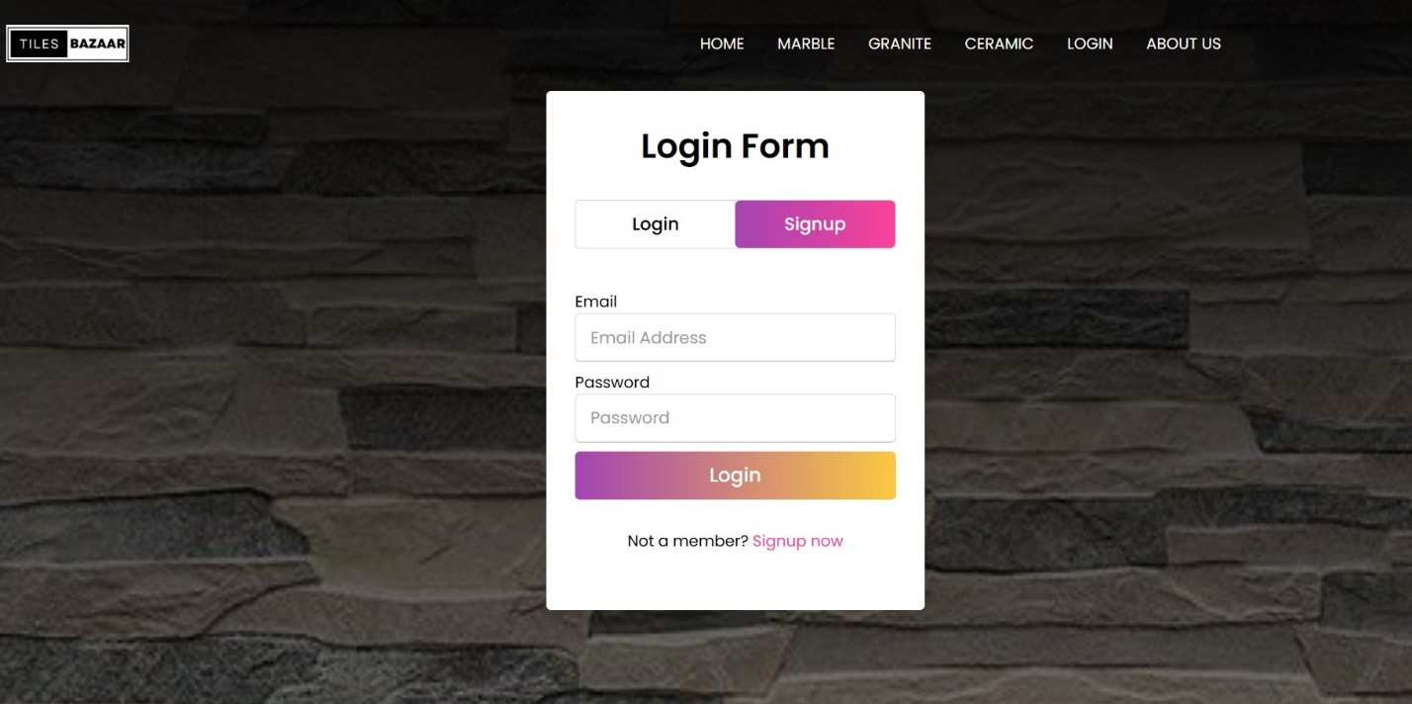

**Fig.4.2 Login Screen**

The login page consists of the navbar and holds the login and the sign-up form which the user can use to access the page’s services.

5

**4.3. Home Webpage** 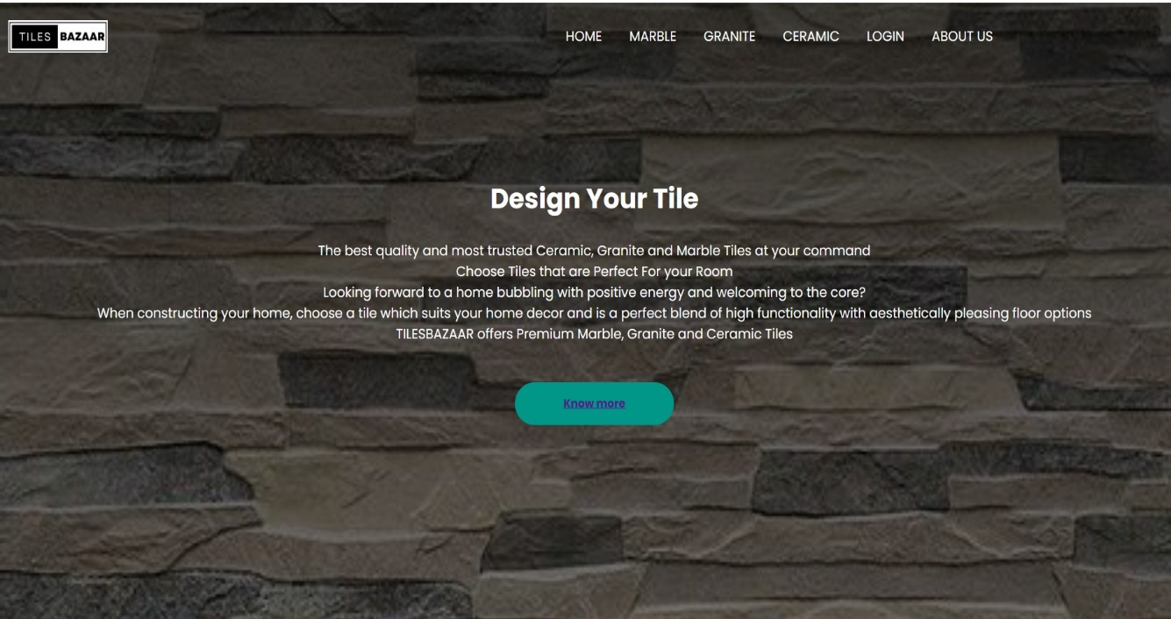

**Fig.4.3 Home Page**

The Home page consists of the navbar, a brief information about the website’s offerings, a checkout page and buttons to perform certain actions. At the bottom, the page consists of information on ways to contact the company.

The navigation bar consists of links heading to other pages of the website such as Marble, Granite, Ceramic, Login and About Us.

6

Chapter 5:

Conclusion

* Understanding of website design principles: layout, colour scheme, font selection, user experience, etc.
* Hands-on experience with website building tools and technologies: HTML, CSS, JavaScript, CMS, etc.
* Knowledge of web development processes: planning, prototyping, testing, deployment, and maintenance.
* Collaboration skills: working as a team, communicating effectively, and managing tasks and deadlines.
* Understanding of online marketing strategies: SEO, social media, email marketing, etc.
* Adaptability to changes: staying updated with the latest technologies and trends in the industry.
* Problem-solving skills: troubleshooting technical issues and finding creative solutions.
* Importance of user feedback: gathering feedback from target audience and incorporating it into website improvements.

In conclusion, this project has provided us with valuable knowledge and skills that can be applied in our future web development projects.

7

References:

* <https://www.codingnepalweb.com>
* https://www.youtube.com/watch?v=zM&list=g&b_channel=CodeWithHarry
* <https://www.javatpoint.com>
* <https://www.w3schools.com/php/>
* <https://www.tutorialspoint.com/css/index.htm>
* <https://www.geeksforgeeks.org/php-tutorials/>
* <https://www.javascripttutorial.net/>

8